**Course Specialist Test 2 Year 12**

Student name: ________________ Teacher name: ________________

**Task type: Response/Investigation**

**Reading time for this test : 5 mins**

**Working time allowed for this task: 40 mins**

**Number of questions: 7**

**Materials required:** Upto 3 classpads/calculators

Standard items: Pens (blue/black preferred), pencils (including coloured), sharpener, correction fluid/tape, eraser, ruler, highlighters

Special items: Drawing instruments, templates, notes on one unfolded sheet of   
A4 paper, and up to three calculators approved for use in the WACE examinations

**Marks available: 41 marks**

**Task weighting: 13%**

**Formula sheet provided: no but formulae stated on page 2**

**Note: All part questions worth more than 2 marks require working to obtain full marks.**

**Useful formulae**

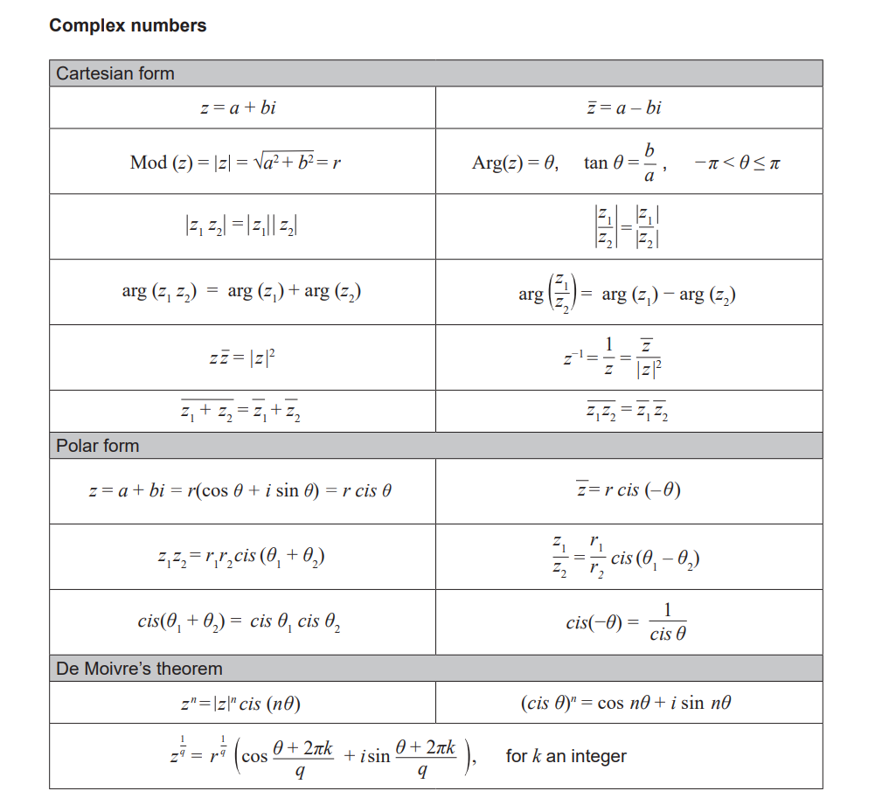



Q1 (2 & 3 = 5 marks)

Consider the function plotted below.

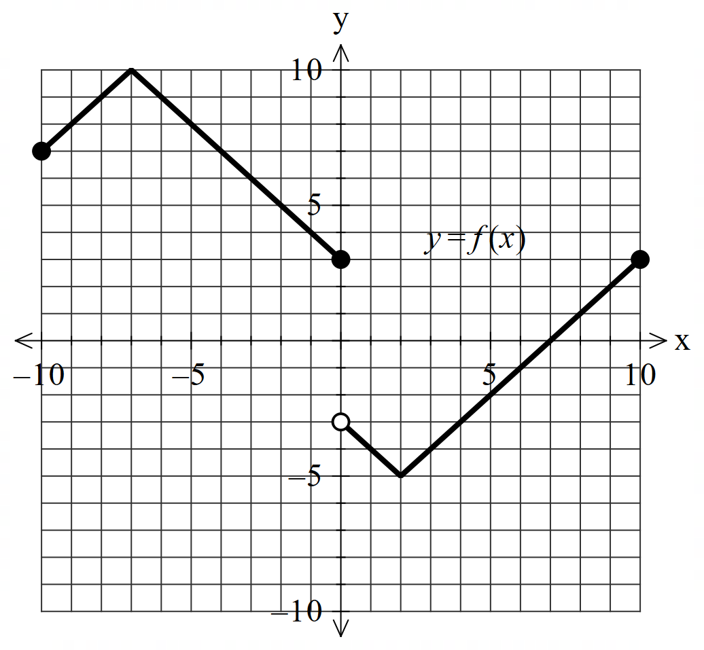

1. Solve for .

|  |
| --- |
|  |
| x=-2,2 |
| **Specific behaviours** |
| P one value  P exactly two values |

1. Sketch  on the axes below.

|  |
| --- |
|  |
|  |
| **Specific behaviours** |
| P y intercept  P Absolute value used to reflect negative y values in x axis  P reflection of right to give new left side |

Q2 (2, 3 & 3 = 8 marks)

Consider the functions  and .

1. Determine the natural domain and range of .

|  |
| --- |
|  |
|  |
| **Specific behaviours** |
| P domain  P range |

1. Does  exist over the natural domain of ? Explain.

|  |
| --- |
|  |
|  |
| **Specific behaviours** |
| P states relevant domain and range  P states reason to exist  P states does not exist with a reason |

1. Determine the largest possible domain for .

|  |
| --- |
|  |
|  |
| **Specific behaviours** |
| P states rule, no need to simplify OR gives reasoning  P determines lower limit of domain (non inclusive)  P determines upper limit of domain (non inclusive)  Do not award if inequality incorrect |

Q3 (3, 3, & 2 = 8 marks)

Consider the function .

1. Determine  and state its domain.

|  |
| --- |
|  |
|  |
| **Specific behaviours** |
| P swaps x and y  P states inverse rule with initially two possibilities  P discards positive and states domain |

Q3 continued

1. Sketch  on the same set of axes below.

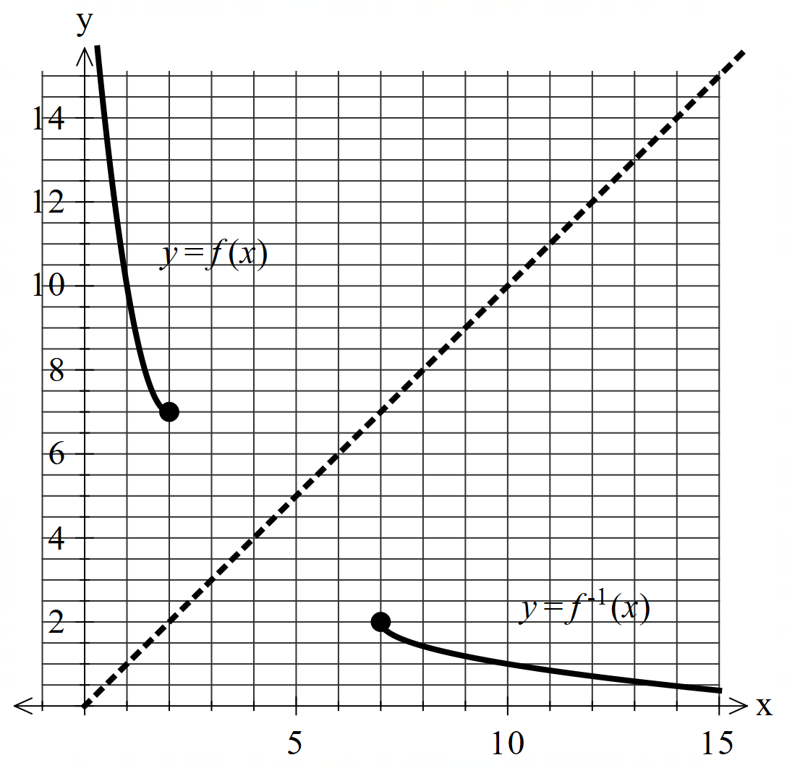

|  |
| --- |
|  |
|  |
| **Specific behaviours** |
| P sketches f with point (2,7) clearly plotted  P sketches f(-1) with point (7,2) clearly plotted  P both functions appear to be reflected in line y=x |

1. Determine value(s) of , if any, such that . Explain.

|  |
| --- |
|  |
| results in  graphs overlapping at these points  From graph above it is apparent that therefore no solutions |
| **Specific behaviours** |
| P explains that results in  P states no solution to equation with a reason |

Q4 (3 marks)

If  is a solution to the equation  where  is a positive real number and  is a positive integer, determine the smallest possible value for in the form . **Justify** your answer.

|  |
| --- |
|  |
|  |
| **Specific behaviours** |
| P establishes a relationship between n and k algebraically  P determines smallest value for n  P expresses r as a power of 3. |

Q5 (3 & 3 = 6 marks)

Consider a triangular plane with vertices shaded as shown below. There is a light globe situated at point .



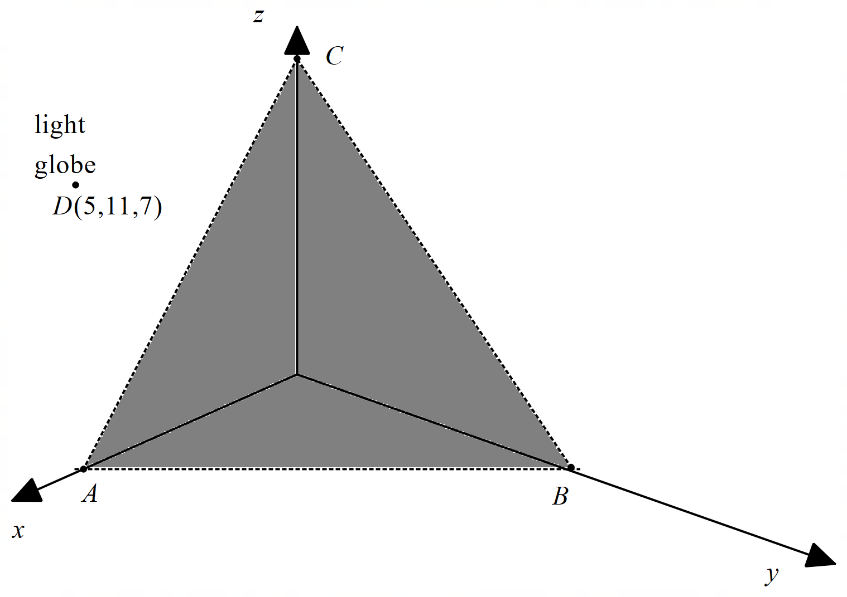

1. Determine the cartesian equation of the shaded plane  above.

|  |
| --- |
|  |
|  |
| **Specific behaviours** |
| P uses cross product using any two sides of triangle  P sets up vector equation of plane  P derives cartesian equation (or any multiple) |

Q5 continued

1. Determine the distance of the globe to the shaded plane .

|  |
| --- |
|  |
|  |
| **Specific behaviours** |
| P determines AD vector or line through pt D  P uses scalar dot product with normal or line meeting plane  P determines approx. distance |

Q6 (5 marks)

Consider the line A  and the sphere B  where  is a real constant.

Determine all possible values of ,to one decimal place such that:

1. the line misses the sphere.
2. the line just touches the sphere.
3. the line pierces the sphere at two points.

|  |
| --- |
|  |
| |  |  | | --- | --- | |  |  | |
| **Specific behaviours** |
| P sets up an equation for  P states a quadratic equation or uses shortest distance approach  P uses discriminant expression or compares distances to radius  P states values of  for all three scenarios  Pstates a condition for **each** of the three scenarios to determine values |

Q7 (3 & 3 = 6 marks)

Consider two rockets  that are ignited at the same time from different positions and move with constant velocities as shown below.



Both rockets leave a smoke trail that stays in the air for at least 6 hours.

1. Determine the distance of the closest approach between the rockets using scalar dot product (3 marks)

|  |
| --- |
|  |
|  |
| **Specific behaviours** |
| P determines expression for separation vector  P uses scalar dot product  P states approx. distance, no need for units |

1. Determine the exact point in space, if any, where the smoke trails overlap at some time in the first 6 hours. (3 marks)

|  |
| --- |
| **c** |
| Smoke trails meet at (7,-5,16)km |
| **Specific behaviours** |
| P uses vector equation of lines  P uses two different parameter variables  P states exact point in space, no need for units  (Max 1 mark if only one parameter used) |

Working out space

Working out space

Working out space

End of test